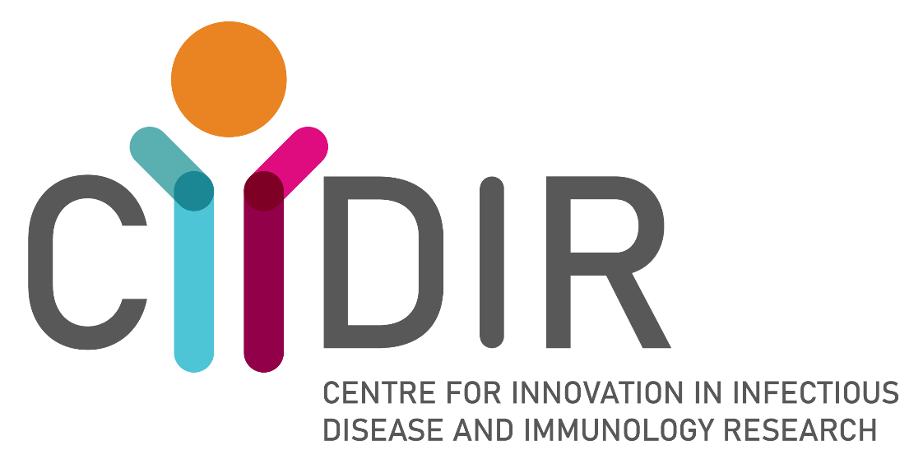

CIIDIR Seed Grant Scheme
2023
Application Guidelines

Seed Grant Summary
Amount: up to $10,000
Duration: 6 - 12 months

Application closing date
Friday 31st March, 2023 at 5pm AEDT

About CIIDIR
CIIDIR is a new initiative of the Deakin University and Barwon Health partnership that will leverage existing strengths in human infectious disease, microbiome and immunology research. Led by Infection, Immunity and Cancer (IIC) theme researchers Alyssa Barry and Eugene Athan, CIIDIR will foster cross-disciplinary collaboration to conduct innovative, locally relevant and internationally important research that will enhance the prevention, control and treatment of infectious (e.g., malaria, staphylococcal infections, COVID-19 and Buruli ulcer) and immune-mediated diseases (e.g. food allergy, asthma and childhood onset diabetes). CIIDIR aims to harness our collective capabilities in these areas to strengthen and build links with external partners as a ‘Hub of Research Excellence’ in population-based infectious disease, microbiome and immunology research. Our vision is to be a Centre that is excellent, collaborative and community-focused that will conduct innovative research on infectious and immune-mediated disease in rural and regional Victoria, Australia and the world.

CIIDIR Seed Grants
An important goal of CIIDIR is to build new research capabilities, capacity and collaborations. In order to do this, the program offers competitive research funding for pilot projects that fall within the research categories of CIIDIR. Projects should complement our Centre’s mission to conduct innovative discovery and translational research on human infectious and immune-mediated diseases to develop novel strategies for prevention, treatment and control. Seed grant applications should support CIIDIR’s vision and strategic directions.

CIIDIR predominately focuses on projects in infectious disease and immune-mediated diseases. There are four main research pillars:
- Molecular biology
- Immunity and Inflammation
- Population Health and Biology
- Clinical and Public Health Research

You should identify which research pillar your proposed project fits within (it may be more than one) and should provide justification of how your project supports CIIDIR’s mission and vision. Please refer to the appendix for more information about the Centre.

Seed Grant applications will be competitively assessed for quality, innovation, potential impact, and likelihood of attracting further funding with larger grants. The Seed Grant scheme encourages independent applications from early and mid-career researchers who are currently working within the research teams of Deakin and Barwon Health investigators and to promote collaborative projects between CIIDIR members and with external partners. Grants are designed to support small pilot projects or small extensions of already established projects that are reasonably achievable within a twelve-month timeframe. We encourage creative ideas and new research. We also encourage new or old collaborations, small projects to complete projects for publication and projects that will promote larger funding sources from 2024.

Successful applications will be awarded at up to $10,000 for a project spanning 6-12 months or upon receipt of the funds, however all funds allocated must be spent by the end of 2023.

Application guidelines
- The lead applicant must be a member of a CIIDIR-affiliated research group (see appendix, Figure 2)
- Collaborative projects involving both Barwon Health and Deakin researchers are strongly encouraged.
- PhD student (post-confirmation), Post-Doctoral Researchers and/or Senior Investigators are all encouraged to apply.
- Projects should be relevant to CIIDIR’s mission and vision.
- CIIDIR promotes collaborative projects and small projects that will lead to publication and/or future funding.
- Complete the application in 12-point font, using single line spacing.
- Adhere to the maximum word limits.
- Complete the application electronically.
- Submit your application by the closing date by email to:
ciidir@deakin.edu.au
- The Seed Grant scheme is administered by Deakin University through CIIDIR.
- The full amount of the grant is to be spent directly on project costs, not for applicant salaries, conference attendance, or items such as laptop computers, required for everyday work.

For Further Information:
Kirsty McCann
Scientific Coordinator
CIIDIR
Email: ciidir@deakin.edu.au

Submissions:
Email: ciidir@deakin.edu.au

CIIDIR Seed grant application

Please fill in the below application in clear, concise paragraphs. Remember to abide by the word limits.
The preliminary budget just needs to be a rough idea. A more detailed budget can be provided after allocation of the seed grant.

If you are interested in a particular technique/method/analysis but currently do not have expertise in this area or a collaborator, we can assist in joining you with a research team that could assist you.

Successful CIIDIR applications could be notified of potential collaboration opportunities with other CIIDIR teams.

Section 1 – Lead Applicant
Lead Applicant name:
Current appointment(s):
Current institution:
Current contact details:
Address
Phone
Email
Other relevant information:
*100 words maximum

Section 2 – Other Applicants
*You can add more applicant boxes if you need to
Applicant name:
Current appointment(s):
Current institution:
Current contact details:
Address
Phone
Email
Role on the project:
*100 words maximum
Applicant name:
Current appointment(s):
Current institution:
Current contact details:
Address
Phone
Email
Role on the project:
*100 words maximum
Applicant name:
Current appointment(s):
Current Institution:
Current contact details:
Address
Phone
Email
Role on the project:
*100 words maximum

Section 3 –Invoicing institution
Institution:
Research Office / Finance Department contact:
Contact details:
Address
Phone
Email

Section 4 – Project details
Project title:
Project location:
Project description:
*300 words maximum.
Research Pillar(s):
Relevance of project to research pillar(s):
*350 words maximum.

CIIDIR Vision and Mission:
Justify how your project support CIIDIR’s mission and vision
*300 words maximum.

Links with existing grants:
*funder and reference number
Translation:
Explain how the project will lead to practical outcomes for infectious and immune-mediated disease
*300 words maximum.

This project requires clearance from a Human Research Ethics Committee | Yes, already approved  Yes, application to be submitted  No

Future funding: Provide details of the further funding for which you will apply during the pilot to continue the research in the future.
*½ page maximum.

Project:
Please provide a brief summary of your proposed project under the subheadings: Background/Rationale; Aims and Hypotheses; Research plan (including methods); Significance and Innovation; Expected Outcomes
*2 pages maximum.

Background/Rationale:
Aims and Hypotheses:
Research Plan (including methods):
Significance and innovation:
Expected Outcomes of your project:
*i.e., extra funding, grant application, publications, collaboration
References:
*½ page maximum.

Preliminary Budget:
*$10,000 maximum
*½ page maximum

Section 5 – Declarations

Declaration by applicant:  I declare that to the best of my knowledge, the information supplied herein is correct and complete. I declare the proposed project supports CIIDIR’s mission and vision. I acknowledge that the submission of incorrect or incomplete information may result in a cancellation of approved funding at any stage.  I confirm that I have: | Name:  Signature:  Date:  Read the CIIDIR Seed Grant Scheme Guidelines and submission requirements  Obtained all required signatures.
Declaration by primary supervisor:  I declare that I have agreed to supervise the applicant on the project detailed above and that I have sufficient time to devote to the applicant and the project. | Name:  Signature:  Date:

Appendix 1:

MISSION:

CIIDIR conducts innovative discovery and translational research on human infectious and immune-mediated diseases to develop novel strategies for prevention, treatment and control.

CIIDIR will leverage capacity in human infectious disease, microbiome and immunology research at Deakin and Barwon Health to provide a laboratory focus for our population-based cohort studies and clinical trials. We will foster cross-disciplinary collaboration to conduct innovative, locally relevant and internationally important research that will enhance the prevention, treatment and control of infectious and immune-mediated diseases. CIIDIR will link with external partners as a ‘Hub of Research Excellence’ in population-based infectious disease, microbiome and immunology research.

VISION:

A Centre that is excellent, collaborative and community-focused with a strong brand, that will conduct innovative research on infectious and immune-mediated disease in rural and regional Victoria, Australia and the world.

ABOUT CIIDIR:

CIIDIR is an initiative of the Deakin University and Barwon Health partnership (Figure 1). The Centre will integrate with and leverage established programs within Deakin University including IMPACT, the Institute for Frontier Materials (IFM), the Institute for Intelligent Systems Research and Innovation (IISRI), the Institute for Health Transformation (IHT), the School of Medicine (SoM), the School of Health & Social Development (SHSD), the School of Life and Environmental Sciences (LES); and Barwon Health including the Department of Infectious Diseases, the Barwon South West Public Health Unit (BSW PHU), the Adrian Costa Clinical Trials Centre and the Australian Rickettsial Reference Laboratory (ARRL). The Centre will maintain strong linkages with existing partners through collaboration with Burnet Institute (including co-funding of the Scientific Director’s salary), CSIRO’s Australian Centre for Disease Preparedness (ACDP) and Murdoch Children’s Research Institute (MCRI). CIIDIR will leverage our collective capacity in infectious diseases and immunology research to partner with the proposed Australian Institute of Infectious Diseases (AIID), linking with a national network to enhance the response to global emerging and existing infectious disease threats both locally, and in the world at large. Flagship programs on Buruli ulcer, COVID-19, malaria, antimicrobial resistance, microbiome and prevention of allergic disease and asthma will be the focus of our research.

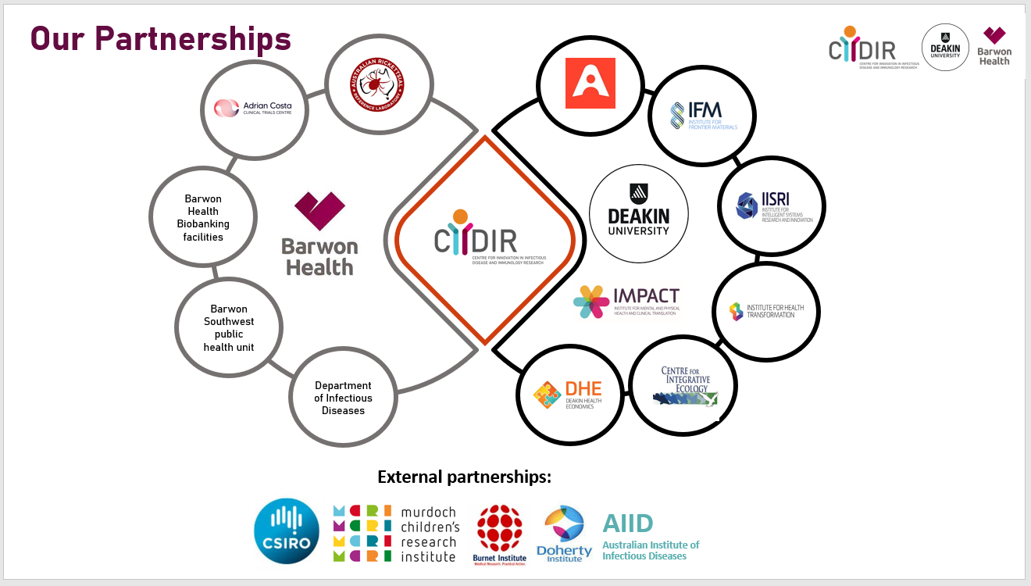
Figure 1. Structure and organization
CIIDIR is a partnership between Deakin and Barwon Health to establish a Strategic Research and Innovation Centre (SRIC). CIIDIR will comprise of research groups from both Barwon Health and Deakin Universities IMPACT Institute, predominantly located in Barwon Health Research labs in the Health Education and Research Building in Geelong, as well as some groups in other locations and not affiliated with IMPACT.
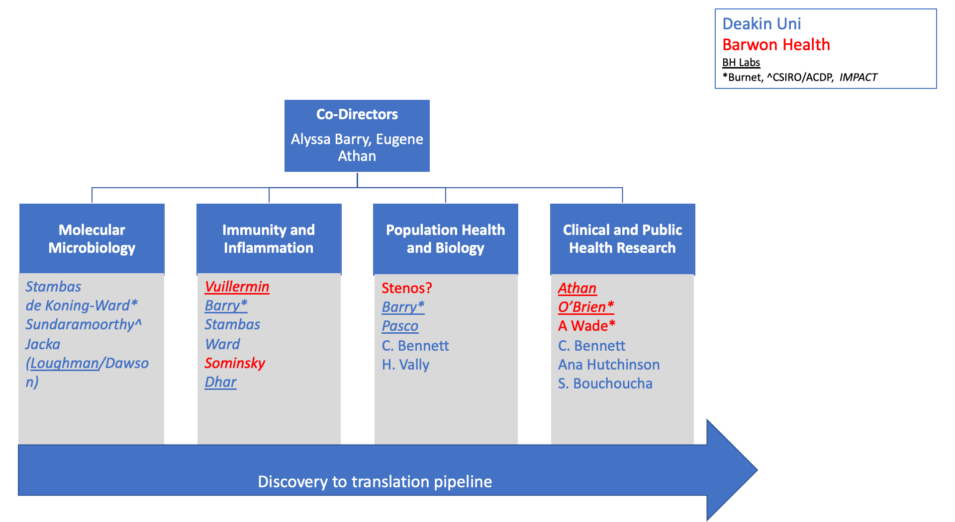
Figure 2. CIIDIR-affiliated Research Groups

PROPOSED MEMBERSHIP AND THEMES:

The core of CIIDIR will expand the Infection, Immunity and Cancer (IIC) Theme of IMPACT, and extend to other areas including Population Health, with research groups based at Barwon Health’s Geelong Hospital, the Health Education and Research Building (HERB), Deakin’s Waurn Ponds and Burwood campuses. The Centre will create a unified laboratory focus for the world-class infectious disease, microbiome, immunology and population health activities taking place across IMPACT, the University as a whole, and at Barwon Health.

Through innovative research in key areas, CIIDIR will build translational platforms for clinical practice innovation and public health policy. CIIDIR activities will be structured into four research “pillars” that span the discovery to translation pipeline that will produce real outcomes for human health (Figure 3).
They include:

- Molecular Microbiology: Fundamental research on host-pathogen and medical device interactions to decipher biological pathways that are critical for infection and inflammation.

- Immunity and Inflammation: Basic and translational research on immunity and inflammation, and microbial diversity (pathogens and microbiome) to inform vaccine and biomarker development and therapeutic interventions.

- Population Health and Biology: Epidemiology and surveillance to understand patterns of disease and disease transmission in human populations, and development of innovative approaches for surveillance. One Health studies focusing on the epidemiology and ecology of infection in animals, and their association with the environment and human health.

- Clinical and Public Health Research: Clinical studies of infectious disease and immune disorders/ Implementation and operational research on public health interventions.

Cross-cutting activities work across all pillars to ensure access to the best training, resources and enabling technologies as well as ensuring discoveries are translated into solutions for human health. Seed Grant project should be directed at one or more of the four research pillars rather than cross-cutting activities.

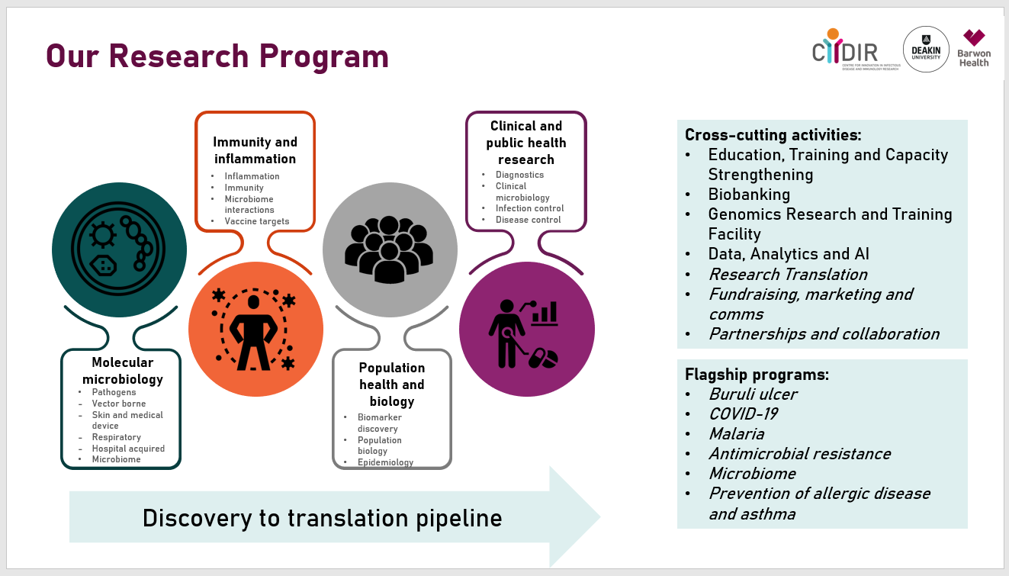
Figure 3. CIIDIR Research Activities

